**Physiotherapist Trainer Using pose Classifier**

**1. Introduction:**

The field of physiotherapy plays a critical role in promoting overall health and well-being by addressing musculoskeletal issues and movement disorders. As part of their training, physiotherapy students and practitioners often need to learn and practice various therapeutic exercises and poses. To enhance their training experience and ensure correct execution, we present a novel approach in this report, the development of a Physiotherapist Trainer using a Support Vector Machine (SVM) classifier for pose recognition.

Recognizing the importance of proper form during exercises, the traditional training methods for physiotherapists have often relied on manual supervision and verbal cues. However, such approaches may be limited by the availability of experienced trainers and real-time feedback. With advancements in computer vision and machine learning, our goal is to bridge this gap by creating an interactive and intelligent system capable of recognizing and providing feedback on various poses commonly used in physiotherapy.

In our proposed system, we utilize the SVM classifier, a popular and robust machine learning algorithm, to perform pose recognition based on image and video inputs. SVM excels in binary classification tasks, making it an ideal choice for identifying predefined poses as "correct" or "incorrect." To develop the SVM model, we construct a comprehensive dataset comprising annotated images and videos of physiotherapy poses, representing a wide range of exercises commonly employed in clinical practice.

The pose recognition process begins with data preprocessing, where images and videos are standardized, and irrelevant features are removed to enhance the SVM model's efficiency. Next, the SVM algorithm learns from the labeled dataset to create decision boundaries that separate different poses, allowing it to classify new, unseen poses accurately.

The Physiotherapist Trainer is designed as an interactive software application, featuring a user-friendly interface. Physiotherapy students and practitioners can interact with the system by either uploading images or videos of themselves performing various exercises or using a webcam for real-time pose recognition during practice sessions. The SVM classifier will then evaluate the input and provide instantaneous feedback, indicating whether the pose is executed correctly or if any adjustments are needed.

The potential impact of the Physiotherapist Trainer is significant. By providing instant feedback and guidance, the system can enhance the learning experience for physiotherapy students, allowing them to refine their technique and gain confidence in executing therapeutic poses accurately. For practicing physiotherapists, the trainer can serve as a valuable tool for continuous improvement and self-assessment.

Furthermore, the system's versatility allows for customization and scalability. As the dataset expands, the SVM model can be trained to recognize an ever-growing range of poses and exercises. This adaptability opens up possibilities for integration with virtual reality environments, telemedicine applications, and remote physiotherapy coaching, offering improved accessibility and convenience for both patients and professionals.

The development of a Physiotherapist Trainer utilizing an SVM classifier for pose recognition holds immense potential in revolutionizing the way physiotherapy is taught and practiced. By combining the power of computer vision and machine learning, this intelligent system enables personalized and real-time feedback for physiotherapy students and practitioners, promoting correct form and ensuring optimal treatment outcomes.

2. **Literature Review:**

Literature Review

* we propose to employ the three main components of a physiotherapy exercise (the motion patterns, the stance knowledge, and the exercise object) as different recognition tasks and embed them separately into the recognition system. The low level information about each component is gathered using machine learning methods. Then, we use a generative Bayesian network to recognize the exercise types by combining the information from these sources at an abstract level, which takes the advantage of domain knowledge for a more robust system. Finally, a novel postprocessing step is employed to estimate the exercise repetitions counts. The performance evaluation of the system is conducted with a new dataset which contains RGB (red, green, and blue) and depth videos of home-based exercise sessions for commonly applied shoulder and knee exercises. The proposed system works without any body-part segmentation, bodypart tracking, joint detection, and temporal segmentation methods. In the end, favorable exercise recognition rates and encouraging results on the estimation of repetition counts are obtained.

[A computerized recognition **HYPERLINK "https://ieeexplore.ieee.org/abstract/document/6819433/"system**HYPERLINK "https://ieeexplore.ieee.org/abstract/document/6819433/"for the home-based HYPERLINK "https://ieeexplore.ieee.org/abstract/document/6819433/"physiotherapy HYPERLINK "https://ieeexplore.ieee.org/abstract/document/6819433/"exercises HYPERLINK "https://ieeexplore.ieee.org/abstract/document/6819433/"using HYPERLINK "https://ieeexplore.ieee.org/abstract/document/6819433/"an RGBD camera](https://ieeexplore.ieee.org/abstract/document/6819433/)

[I HYPERLINK "https://scholar.google.com/citations?user=dCba1z4AAAAJ&hl=en&oi=sra"Ar](https://scholar.google.com/citations?user=dCba1z4AAAAJ&hl=en&oi=sra), [YS HYPERLINK "https://scholar.google.com/citations?user=1qKw6SIAAAAJ&hl=en&oi=sra"Akgul](https://scholar.google.com/citations?user=1qKw6SIAAAAJ&hl=en&oi=sra) - IEEE Transactions on Neural **Systems**and …, 2014 - ieeexplore.ieee.org

* In this paper, we propose a Yoga pose assessment method using pose detection to help the self-learning of Yoga. The system first detects a Yoga pose using multi parts detection only with PC camera. Then, it calculates the difference of the specified body angles between the pose of an instructor and that of a user. Then, it calculates the difference of the specified body angles between the pose of an instructor and that of a user, and suggests the correction if larger than the given threshold. The total angle difference values are calculated averagely and defined as performance class level in Table 1. For evaluations, we applied the proposal to three persons with three Yoga poses of basic and easy Yoga poses for beginners and confirmed that it found the incorrect parts of each pose.

[A proposal of **HYPERLINK "https://ieeexplore.ieee.org/abstract/document/8920892/"yoga poseHYPERLINK "https://ieeexplore.ieee.org/abstract/document/8920892/"**HYPERLINK "https://ieeexplore.ieee.org/abstract/document/8920892/"assessment method HYPERLINK "https://ieeexplore.ieee.org/abstract/document/8920892/"using pose detection HYPERLINK "https://ieeexplore.ieee.org/abstract/document/8920892/"for self-HYPERLINK "https://ieeexplore.ieee.org/abstract/document/8920892/"learning](https://ieeexplore.ieee.org/abstract/document/8920892/)

MC Thar, [KZN Winn](https://scholar.google.com/citations?user=SmVB4_sAAAAJ&hl=en&oi=sra), N Funabiki - … International conference on …, 2019 - ieeexplore.ieee.org

* The proposed system is aimed at providing concise feedback to the practitioner so they are able perform yoga poses correctly and assist them in identifying the incorrect poses and suggest a proper feedback for improvement in order to prevent injuries as well as increase their knowledge of a particular yoga pose. A data-set of Five Yoga pose (i.e. Natarajasana and Trikonasana, and Vrikshasana and Virbhadrasana 1 & 2 and Utkatasana) has been created from collecting images from the Internet as well as from different individuals that took part in development of this system.A deep learning model is proposed which uses convolutional neural networks (CNN) for yoga pose identification along with a human joints localization model followed by a process for identification of errors in the pose for developing the system. Using the proposed system we have been able to achieve a classification accuracy of 95% for pose identification. After obtaining all the information about the pose of the user the system gives feedback to improve or correct the posture of the user.

[YogHYPERLINK "https://ieeexplore.ieee.org/abstract/document/9509937/"-guru: Real-time **HYPERLINK "https://ieeexplore.ieee.org/abstract/document/9509937/"yoga HYPERLINK "https://ieeexplore.ieee.org/abstract/document/9509937/"pose**HYPERLINK "https://ieeexplore.ieee.org/abstract/document/9509937/" HYPERLINK "https://ieeexplore.ieee.org/abstract/document/9509937/"correction HYPERLINK "https://ieeexplore.ieee.org/abstract/document/9509937/"system using HYPERLINK "https://ieeexplore.ieee.org/abstract/document/9509937/"deep HYPERLINK "https://ieeexplore.ieee.org/abstract/document/9509937/"learning HYPERLINK "https://ieeexplore.ieee.org/abstract/document/9509937/"methods](https://ieeexplore.ieee.org/abstract/document/9509937/)

A Chaudhari, O Dalvi, O Ramade… - 2021 International …, 2021 - ieeexplore.ieee.org

* In this paper, we propose a Yoga posture recognition system, which is capable of recognizing what Yoga posture the practitioner is performing, and then retrieving Yoga training information from Internet to remind his/her attention to the posture. First, a Kinect is used for capturing the user body map and extracting the body contour. Then, star skeleton, which is a fast skeletonization technique by connecting from centroid of target object to contour extremes, is used as a representative descriptor of human posture for Yoga posture recognition. Finally, some Yoga training information for the recognized posture can be retrieved from Internet to remind the practitioner what to pay attention to when practicing the posture.

[**Yoga posture recognition**HYPERLINK "https://link.springer.com/chapter/10.1007/978-3-319-04114-8_42"for self-HYPERLINK "https://link.springer.com/chapter/10.1007/978-3-319-04114-8_42"training](https://link.springer.com/chapter/10.1007/978-3-319-04114-8_42)

HT Chen, YZ He, CC Hsu, [CL Chou](https://scholar.google.com/citations?user=AmWA1bsAAAAJ&hl=en&oi=sra), SY Lee… - … Conference, MMM 2014 …, 2014 - Springer

* In this paper, deep learning-based techniques are developed to detect incorrect yoga posture. With this method, the users can select the desired pose for practice and can upload recorded videos of their yoga practice pose. The user pose is sent to train models that output the abnormal angles detected between the actual pose and the user pose. With these outputs, the system advises the user to improve the pose by specifying where the yoga pose is going wrong. The proposed method was compared to several state-of-the-art methods, and it achieved outstanding accuracy of 0.9958 while requiring less computational complexity.

[**Yoga HYPERLINK "https://www.hindawi.com/journals/cin/2022/4311350/"pose**HYPERLINK "https://www.hindawi.com/journals/cin/2022/4311350/" estimation HYPERLINK "https://www.hindawi.com/journals/cin/2022/4311350/"and feedback generation HYPERLINK "https://www.hindawi.com/journals/cin/2022/4311350/"using HYPERLINK "https://www.hindawi.com/journals/cin/2022/4311350/"deep HYPERLINK "https://www.hindawi.com/journals/cin/2022/4311350/"learning](https://www.hindawi.com/journals/cin/2022/4311350/)

V Anand Thoutam, [A HYPERLINK "https://scholar.google.com/citations?user=BFAy3MUAAAAJ&hl=en&oi=sra"Srivastava](https://scholar.google.com/citations?user=BFAy3MUAAAAJ&hl=en&oi=sra), [T HYPERLINK "https://scholar.google.com/citations?user=t9NMjp8AAAAJ&hl=en&oi=sra"Badal](https://scholar.google.com/citations?user=t9NMjp8AAAAJ&hl=en&oi=sra)… - Computational …, 2022 - hindawi.com

* Pose detection estimate human activity in images or video frames using computer vision technique. Pose detection has many applications, such as body to augmented reality, fitness, animation etc. ExNET represents a way to detect human pose from 2D human exercises image using Convolutional Neural Network. In recent time Deep Learning based systems are making it possible to detect human exercise poses from images. We refer to the model we have built for this task as ExNET: Deep Neural Network for Exercise Pose Detection. We have evaluated our proposed model on our own dataset that contains a total of 2000 images. And those images are distributed into 5 classes as well as images are divided into training and test dataset, and obtained improved performance. We have conducted various experiments with our model on the test dataset, and finally got the best accuracy of 82.68%.

[ExNETHYPERLINK "https://link.springer.com/chapter/10.1007/978-981-13-9181-1_17": deep neural network for **HYPERLINK "https://link.springer.com/chapter/10.1007/978-981-13-9181-1_17"exercise**HYPERLINK "https://link.springer.com/chapter/10.1007/978-981-13-9181-1_17"pose HYPERLINK "https://link.springer.com/chapter/10.1007/978-981-13-9181-1_17"detection](https://link.springer.com/chapter/10.1007/978-981-13-9181-1_17)

S Haque, [AKMSA HYPERLINK "https://scholar.google.com/citations?user=_Rm1Xk4AAAAJ&hl=en&oi=sra"Rabby](https://scholar.google.com/citations?user=_Rm1Xk4AAAAJ&hl=en&oi=sra), MA Laboni, [N HYPERLINK "https://scholar.google.com/citations?user=oH4oMBgAAAAJ&hl=en&oi=sra"Neehal](https://scholar.google.com/citations?user=oH4oMBgAAAAJ&hl=en&oi=sra)… - … **in Image Processing** …, 2019 - Springer

* This research proposes an interactive system capable of recognizing 6 poses for learning Yoga that can track up to 6 people at the same time. It is also integrated with command voices to visualize the instructions and pictures about the poses to be performance for the user. In order to get a strong database for recognition, the system used Adaboost algorithm though the software development kit specially for Kinect. All data was trained by an expert yoga trainer and final database showed above 94.78% as maximum value for poses analyzed in terms of accuracy.

[**Recognition**HYPERLINK "https://ieeexplore.ieee.org/abstract/document/8443267/"of HYPERLINK "https://ieeexplore.ieee.org/abstract/document/8443267/"yoga poses through HYPERLINK "https://ieeexplore.ieee.org/abstract/document/8443267/"an interactive HYPERLINK "https://ieeexplore.ieee.org/abstract/document/8443267/"system with HYPERLINK "https://ieeexplore.ieee.org/abstract/document/8443267/"kinectHYPERLINK "https://ieeexplore.ieee.org/abstract/document/8443267/" device](https://ieeexplore.ieee.org/abstract/document/8443267/)

EW Trejo, P Yuan - 2018 2nd international conference on …, 2018 - ieeexplore.ieee.org

* This paper proposes a framework to track the progress in angles and range of motion of joints in physiotherapy. Using a sensor, the 3D skeletal information of a subject undergoing the therapy is extracted. Using time-frequency features of the skeletal profile based on the approximation coefficients of the Discrete Wavelet Transform (DWT), the exercise the subject is engaged in is identified by a recurrent neural network in conjunction with long-and-short term memory. Subsequently, each instance of the exercise is segmented. The best of these is used as a reference and various instances of the exercise are compared against the reference for repeatability, fidelity, etc., to study muscle and/ or joint fatigue and progress. Finally, Joint performance analysis is carried out using metrics evaluated at the end of each engaging session. Experimental results demonstrate that with such progressive analysis, it is possible to quantify the performance through the course of the regimen.

Analysis of joints for tracking **fitness**and monitoring progress **in physiotherapy**

[N HYPERLINK "https://scholar.google.com/citations?user=33De4NEAAAAJ&hl=en&oi=sra"Rao](https://scholar.google.com/citations?user=33De4NEAAAAJ&hl=en&oi=sra), PM Surana, [R HYPERLINK "https://scholar.google.com/citations?user=lHiU2gcAAAAJ&hl=en&oi=sra"Ragesh](https://scholar.google.com/citations?user=lHiU2gcAAAAJ&hl=en&oi=sra)… - … and **Image Processing** …, 2019 - ieeexplore.ieee.org

* With this method, the physiotherapist can make sure that the therapy sessions match how well the patient is getting better. Furthermore, we aim to bring physical therapy to the metaverse by developing a telehealth platform that addresses the shortcomings of traditional videoconferencing-style platforms encountered by therapists in recent years. Physical therapists are currently unable to obtain quantifiable metrics such as range of motion, joint torques, or balance assessment using current 2D platforms. Our goal is to help therapists by providing these metrics in real time, allowing patients to be properly evaluated via remote care. By all means, remote care improves patient accessibility, reduces commuting time, and can help increase the number of touchpoints between therapist and patient.

[Human pose estimation for **HYPERLINK "https://search.ebscohost.com/login.aspx?direct=true&profile=ehost&scope=site&authtype=crawler&jrnl=18245463&AN=162228866&h=zG73yAvA7k3vmtG2QE1BZIlFAqD8PXGLLfiLh3g6gKITe2YtceDx5UW1XuxNzL46I3vkgwY9LlBvBDwT%2FqqIUQ%3D%3D&crl=c"physiotherapy**HYPERLINK "https://search.ebscohost.com/login.aspx?direct=true&profile=ehost&scope=site&authtype=crawler&jrnl=18245463&AN=162228866&h=zG73yAvA7k3vmtG2QE1BZIlFAqD8PXGLLfiLh3g6gKITe2YtceDx5UW1XuxNzL46I3vkgwY9LlBvBDwT%2FqqIUQ%3D%3D&crl=c"following a car accident HYPERLINK "https://search.ebscohost.com/login.aspx?direct=true&profile=ehost&scope=site&authtype=crawler&jrnl=18245463&AN=162228866&h=zG73yAvA7k3vmtG2QE1BZIlFAqD8PXGLLfiLh3g6gKITe2YtceDx5UW1XuxNzL46I3vkgwY9LlBvBDwT%2FqqIUQ%3D%3D&crl=c"using HYPERLINK "https://search.ebscohost.com/login.aspx?direct=true&profile=ehost&scope=site&authtype=crawler&jrnl=18245463&AN=162228866&h=zG73yAvA7k3vmtG2QE1BZIlFAqD8PXGLLfiLh3g6gKITe2YtceDx5UW1XuxNzL46I3vkgwY9LlBvBDwT%2FqqIUQ%3D%3D&crl=c"depth-wise separable convolutional neural networks.](https://search.ebscohost.com/login.aspx?direct=true&profile=ehost&scope=site&authtype=crawler&jrnl=18245463&AN=162228866&h=zG73yAvA7k3vmtG2QE1BZIlFAqD8PXGLLfiLh3g6gKITe2YtceDx5UW1XuxNzL46I3vkgwY9LlBvBDwT%2FqqIUQ%3D%3D&crl=c)

[A HYPERLINK "https://scholar.google.com/citations?user=sVafmtUAAAAJ&hl=en&oi=sra"Tannoury](https://scholar.google.com/citations?user=sVafmtUAAAAJ&hl=en&oi=sra), EM Choueiri… - Advances **in** …, 2023 - search.ebscohost.com

3. **Research gap:**

The development of a Physiotherapist Trainer using an SVM classifier for pose recognition represents a promising and innovative application of computer vision and machine learning in the field of physiotherapy. While this technology holds great potential, there are still some research gaps that need to be addressed to fully optimize the system's performance and its integration into physiotherapy practice. This section explores the key research gaps in this area:

1. **Limited Dataset Diversity:**

One of the primary challenges in developing a robust SVM-based pose recognition system is the availability of diverse and comprehensive datasets. An effective SVM model requires a large dataset comprising a wide range of physiotherapy poses, executed by individuals with different body types, fitness levels, and demographic backgrounds. The lack of diversity in the dataset may lead to biased decision boundaries and reduced generalizability of the model. To address this gap, efforts should be made to curate extensive and diverse datasets representing various physiotherapy exercises to improve the model's accuracy and versatility.

2. **Real-Time Feedback Accuracy:**

The success of the Physiotherapist Trainer lies in its ability to provide accurate and real-time feedback on pose execution. However, achieving precise pose recognition in real-time can be challenging, particularly in dynamic exercises with rapid movements. Delays in feedback or incorrect evaluations may hinder the effectiveness of the training system. Addressing this research gap requires exploring techniques for optimizing pose recognition algorithms to reduce latency and improve accuracy during real-time use.

3. **Handling Pose Variability:**

Physiotherapy exercises often involve variations in form and posture, making pose recognition a complex task. Different individuals may execute the same exercise with slight variations, leading to pose ambiguity for the classifier. The system should be able to recognize valid variations of poses while maintaining strict form standards to avoid false positives or negatives. Developing algorithms that can account for pose variability and adapt to individual differences is crucial in bridging this research gap.

4. **Fine-Grained Feedback:**

While current SVM-based pose recognition systems can classify poses as "correct" or "incorrect," providing more fine-grained feedback can enhance the learning experience. For instance, identifying specific areas where form improvement is needed or suggesting corrective measures can be invaluable for physiotherapy students and practitioners. Implementing such granular feedback requires exploring advanced computer vision techniques and pose estimation algorithms.

5. **User Interface and Interaction:**

The success of the Physiotherapist Trainer heavily depends on its user interface and interaction design. Ensuring that the system is intuitive, user-friendly, and suitable for various user demographics is essential. The interface should facilitate easy input of images and videos for pose recognition, and the feedback should be presented in a clear and understandable manner. Conducting user studies and incorporating user feedback during the design process can help bridge this research gap and optimize the trainer's usability.

6. **Transfer Learning and Generalization:**

In order to scale the Physiotherapist Trainer to recognize a broader range of physiotherapy poses, exploring transfer learning techniques becomes essential. Transfer learning allows the model to leverage knowledge from pre-trained classifiers for related tasks. Adapting transfer learning methods for pose recognition can significantly reduce the amount of labeled data required to expand the system's capabilities. Moreover, ensuring the model's generalization across different physiotherapy exercises and interventions is crucial for its practicality in diverse clinical settings.

**4. Initial interfact progress:**

This section outlines the journey we embarked upon, from data collection and annotation to classifier selection and performance evaluation, empowering the Physiotherapist Trainer to deliver personalized and invaluable feedback to physiotherapy students and practitioners.

1. **Data Collection and Annotation:**

Our journey began with an extensive data collection effort. We curated a diverse and comprehensive dataset, encompassing a wide range of physiotherapy poses performed by individuals with varying body types, fitness levels, and demographics. Each image and video in the dataset was meticulously annotated by our team of experts, providing accurate labels indicating the specific pose being performed. These ground truth annotations laid the foundation for supervised learning, enabling the classifier to learn from labeled examples during the training process.

2. **Data Preprocessing and Augmentation:**

To optimize the classifier's performance, we applied rigorous data preprocessing techniques. We standardized the data by resizing all images to a uniform resolution and normalizing pixel values within a specific range. Data augmentation was a crucial step to increase dataset variability and mitigate overfitting risks during training. Through transformations such as rotations, flips, and shifts, we enriched the dataset, ensuring the classifier's ability to generalize effectively to unseen data.

3. **Feature Extraction and Selection:**

Extracting meaningful features from the dataset was vital for accurate pose recognition. We explored various techniques, including Histogram of Oriented Gradients (HOG) and deep learning-based Convolutional Neural Network (CNN) features, to derive informative representations of the poses. Additionally, we carefully selected relevant features to enhance the classifier's efficiency and improve its ability to discern crucial pose characteristics.

4. **Classifier Selection:**

The choice of the appropriate classifier played a pivotal role in the success of the Physiotherapist Trainer. After careful evaluation, we determined that Support Vector Machines (SVM) classifiers were the ideal choice for the binary pose recognition task. SVM's capability to identify effective decision boundaries between different poses made it a perfect fit for our system. The selection process factored in considerations such as dataset size, problem complexity, and available computational resources.

5. **Training and Validation Split:**

To assess the classifier's performance, we split the dataset into training and validation sets. The classifier was trained on the training set, while the validation set was used to evaluate its performance during training. This essential step allowed us to fine-tune hyperparameters, prevent overfitting, and ensure that the classifier could generalize accurately to new, unseen data.

6**. Performance Metrics and Baseline Comparison:**

Defining appropriate performance metrics was paramount for evaluating the classifier's effectiveness. We utilized metrics such as accuracy, precision, recall, F1-score, and the confusion matrix to quantitatively assess the classifier's ability to correctly classify poses. Additionally, we compared the classifier's results against simpler approaches and even human expert performance to establish a baseline for comparison, gaining valuable insights into the system's potential for improvement.

1. Examplary 82 pose

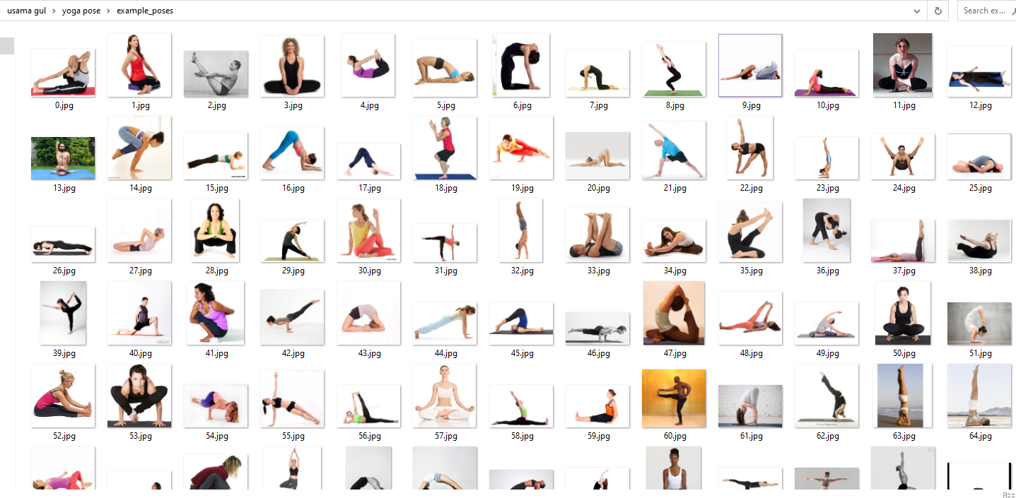

1. Pikel trained SVM model file

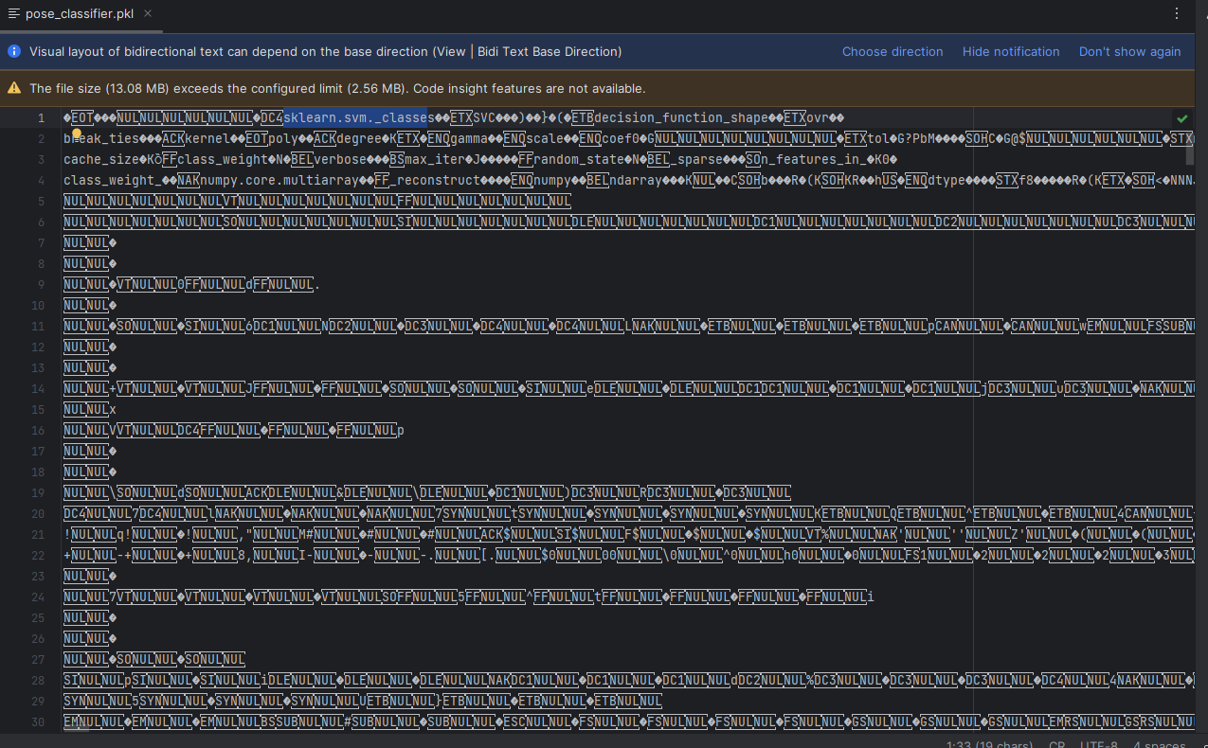

1. Pose list

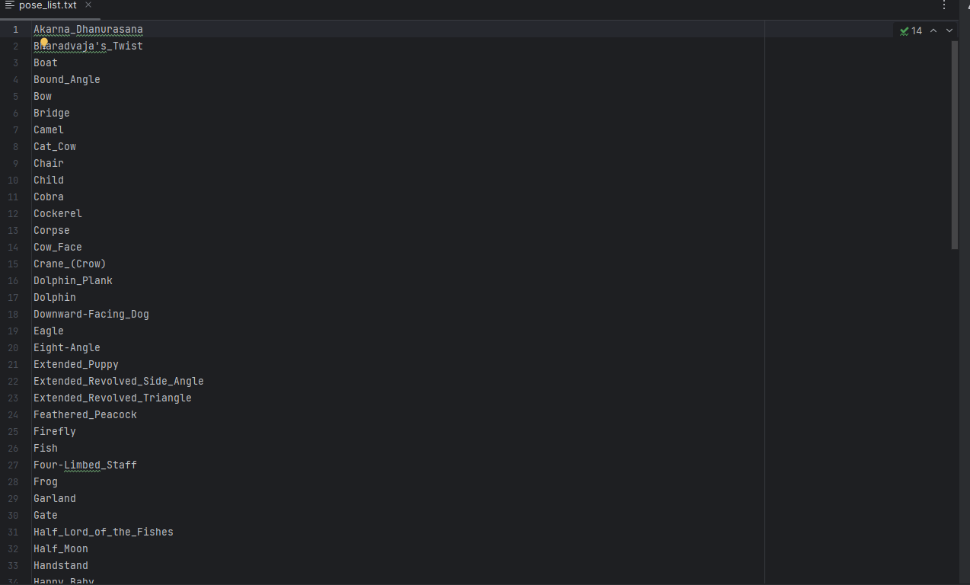

1. Code file

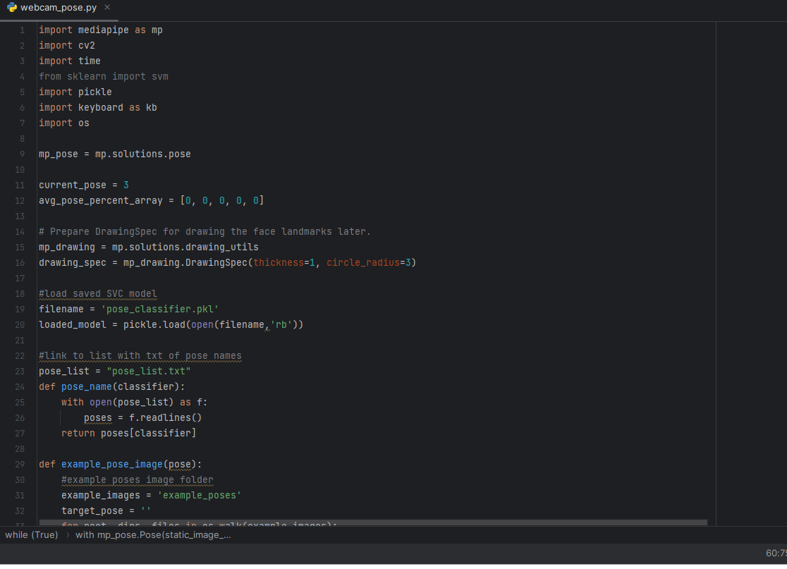

1. Prdictiing Matching between pose

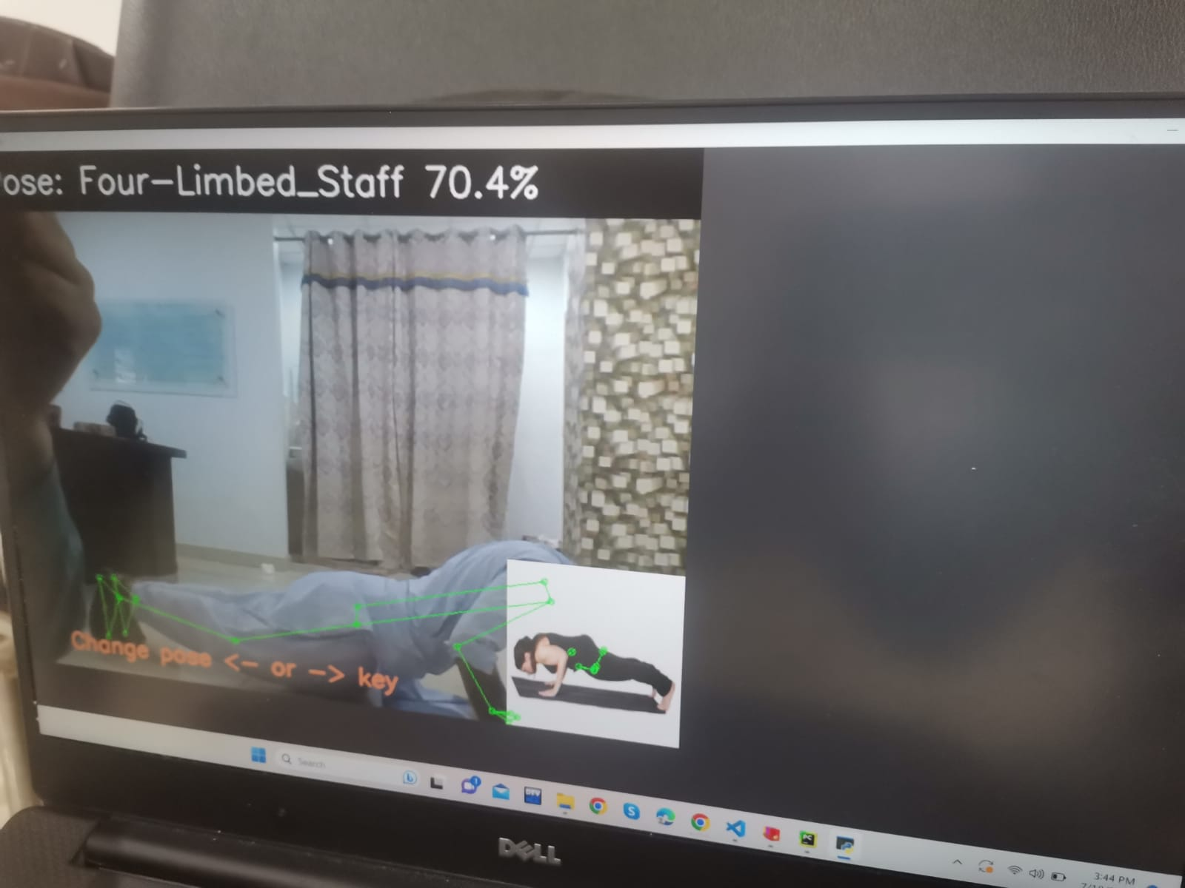

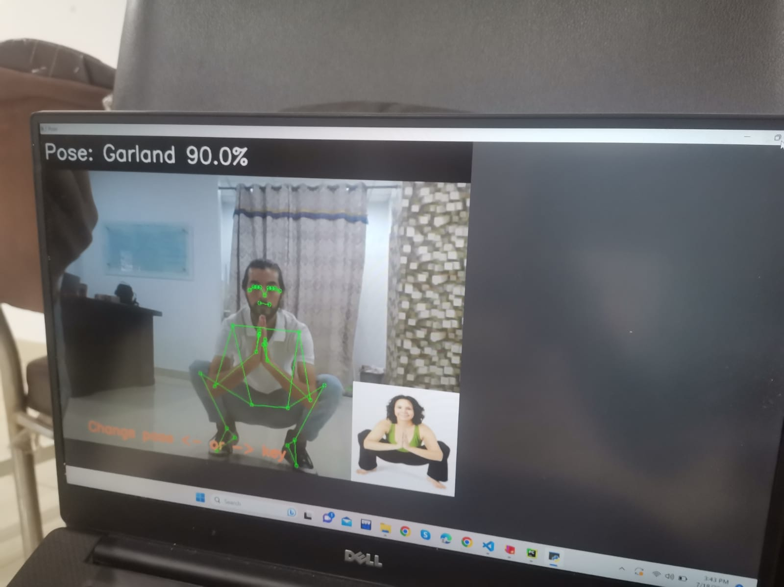

**Future plans**

1.**User-Friendly Webcam Preview:**

Upon launching the GUi, users are greeted with a user-friendly and visually appealing interface. The primary focus is on the webcam preview area, where users can see themselves performing the physiotherapy exercises in real-time. This live feed serves as the input for the pose classification system.

2.**Pose Classification Area:**

Adjacent to the webcam preview, a dedicated "Pose Classification Area" displays the real-time predictions of the user's pose matching. The pose classification system, powered by an SVM classifier, rapidly processes the webcam feed and evaluates the user's pose accuracy. The interface provides instant visual feedback to indicate whether the pose is correctly executed or if adjustments are required.

3.**Visual Feedback Indicators:**

To offer clear and actionable feedback, the interface utilizes visual indicators. When the SVM classifier recognizes the pose as correct, a prominent green checkmark symbol appears on the screen, reassuring users that they are performing the exercise accurately. Conversely, if the classifier detects any discrepancies in the pose, a distinct red "X" symbol prompts users to make necessary corrections.

4.**Guidance and Correction:**

Acknowledging the importance of refining pose execution, the interface offers additional guidance and correction assistance. When the SVM classifier identifies an incorrect pose, a user-friendly pop-up window appears, providing textual instructions on how to correct the form. These instructions are tailored to the specific exercise being performed, offering personalized guidance for each pose.

5.**Exercise Selection Option:**

To enhance the training experience, the interface incorporates an "Exercise Selection" option. Users can choose from a diverse list of physiotherapy exercises through a convenient dropdown menu. As users switch exercises, the SVM classifier adapts accordingly, ensuring accurate classification across a wide range of poses.

6.**User Performance Tracking:**

The interface features an insightful performance tracking mechanism to motivate continuous progress and improvement. As users engage in various exercises over time, the trainer records their performance data, including the number of correct and incorrect poses executed. This data is stored in the background and can be accessed by users to monitor their progress and identify areas for enhancement.

7.**System Status and Connectivity:**

To ensure a seamless user experience, the interface incorporates a "System Status" indicator, offering real-time feedback on the webcam's functionality and classifier connectivity. A green light signals that the webcam and classifier are operating smoothly, while a red light indicates any potential issues that may require attention.